**4: Install AWS Load Balancer Controller using HELM**

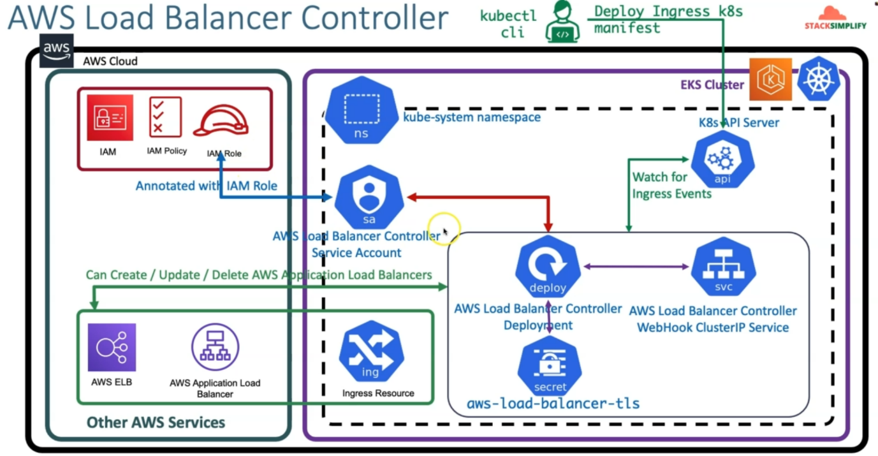

--- **note** – already we have created IAM, IAM policy, IAM Role and aws load balancer controller service account. We have annotated the service account with IAM role.

--- whatever we seeing in this box. They are AWS load balancer controller deployment and it **equilent** secrets called aws-load-balancer-tls. We will also create AWS load balancer controller webhook clusterip service.

--- we will use helm to the above jobs.

**Install the AWS Load Balancer Controller using Helm V3**

**Install Helm**

--- Install Helm if not installed - <https://helm.sh/docs/intro/install/>

--- Install Helm for AWS EKS - <https://docs.aws.amazon.com/eks/latest/userguide/helm.html>

**# Install Helm (if not installed) MacOS**

--- **brew install helm**

**# Verify Helm version**

--- **helm version**

**Install AWS Load Balancer Controller**

--- **Important-Note-1**: If you're deploying the AWS load balancer controller to Amazon EC2 nodes that have restricted access to the Amazon EC2 instance metadata service (IMDS), or if you're deploying to Fargate, then add the following flags to the command that you run:

--- **--set region=region-code**

--- **--set vpcId=vpc-xxxxxxxx**

--- **Important-Note-2**: If you're deploying to any Region other than us-west-2, then add the following flag to the command that you run, replacing account and region-code with the values for your region listed in Amazon EKS add-on container image addresses.

--- Get Region Code and Account info - <https://docs.aws.amazon.com/eks/latest/userguide/add-ons-images.html>

--- **--set image.repository=account.dkr.ecr.region-code.amazonaws.com/amazon/aws-load-balancer-controller**

**# Add the eks-charts repository.**

--- **helm repo add eks https://aws.github.io/eks-charts**

**# Update your local repo to make sure that you have the most recent charts.**

--- **helm repo update**

**# Install the AWS Load Balancer Controller.**

**## Template**

--- **helm install aws-load-balancer-controller eks/aws-load-balancer-controller \**

**-n kube-system \**

**--set clusterName=<cluster-name> \**

**--set serviceAccount.create=false \**

**--set serviceAccount.name=aws-load-balancer-controller \**

**--set region=<region-code> \**

**--set vpcId=<vpc-xxxxxxxx> \**

**--set image.repository=<account>.dkr.ecr.<region-code>.amazonaws.com/amazon/aws-load-balancer-controller**

**## Replace Cluster Name, Region Code, VPC ID, Image Repo Account ID and Region Code**

--- **helm install aws-load-balancer-controller eks/aws-load-balancer-controller \**

**-n kube-system \**

**--set clusterName=eksdemo1 \**

**--set serviceAccount.create=false \**

**--set serviceAccount.name=aws-load-balancer-controller \**

**--set region=us-east-1 \**

**--set vpcId=vpc-0165a396e41e292a3 \ # download the vpc id from aws vpc section.**

**--set image.repository=602401143452.dkr.ecr.us-east-1.amazonaws.com/amazon/aws-load-balancer-controller**

**Sample output for AWS Load Balancer Controller Install steps**

**## Sample Ouput for AWS Load Balancer Controller Install steps**

--- **helm install aws-load-balancer-controller eks/aws-load-balancer-controller \**

**> -n kube-system \**

**> --set clusterName=eksdemo1 \**

**> --set serviceAccount.create=false \**

**> --set serviceAccount.name=aws-load-balancer-controller \**

**> --set region=us-east-1 \**

**> --set vpcId=vpc-0570fda59c5aaf192 \**

**> --set image.repository=602401143452.dkr.ecr.us-east-1.amazonaws.com/amazon/aws-load-balancer-controller**

NAME: aws-load-balancer-controller

LAST DEPLOYED: Wed Feb 2 10:33:57 2022

NAMESPACE: kube-system

STATUS: deployed

REVISION: 1

TEST SUITE: None

NOTES:

AWS Load Balancer controller installed!



